GOOGLE ADWORDS CAMPAIGN DETAILS

|  |  |
| --- | --- |
| * Campaign name | GetSetHome |
| Network type | Search and Display |
| * Name of Ad Groups | Kharadi, Baner, Hinjewadi, Viman Nagar, Kalyani Nagar, Koregaon Park, Pune, |
| * Time and location | India |
| * Total money spent | $183 |
| * CTR | 6.72% |
| * Impressions | 72.6K |
| * CPC | $0.10 |

|  |  |  |
| --- | --- | --- |
| **AdAdGroup** | **KeywordKeywords** | **Ads Active in Last Week** |
| Baner | |  | | --- | | * 1 bhk flats in rent baner | | * flats on rent in baner | |  |
| Hinjewadi | |  | | --- | | * flats on rent in hinjewadi | | * 1 bhk for rent in hinjewadi | | * pg for girls in hinjewadi | | * pg for boys in hinjewadi | | * flats near accenture pune | | * flats near Infosys Pune | |  |
| Kalyani Nagar | |  | | --- | | * flats for rent in kalyani nagar | | * flats on rent in magarpatta | | * pg in kalyani nagar | | * rooms on rent in kalyani nagar | | * pg for girls in kalyani nagar | | * flats near amdocs pune | | * 2 BHK flat in kalyani nagar | |  |
| Kharadi | |  | | --- | | * flats for rent in kharadi | | * room on rent in kharadi | | * pg for girls in kharadi | | * rent flats near kharadi | | * flats near eon IT park | | * pg in kharadi | |  |
| Koregaon Park | |  | | --- | | * pg in koregaon park | | * flats in koregaon park pune for rent | | * pg near koregaon park pune | | * rent flats in koregaon park | |  |
| Pune | |  | | --- | | * apartments for rent in pune | | * flat for rent in pune | | * flats for rent pune | | * flats on rent in pune | | * house on rent in pune | | * flats for sale in pune | | * room on rent in pune | | * 1 bhk flat on rent in kharadi pune | | * 2 bhk flat on rent in kharadi pune | | * 2 bhk for rent in kharadi pune | | * room rent in kharadi pune | | * rent house in pune | | * offices on rent in pune | | * flats on rent in baner pune without brokerage | | * property on rent in pune | | * pune guest house rent | | * no brokerage flats in pune | | * one rk on rent in pune | | * pg for girls in pune | | * pg in pune | | * rk on rent in pune | | * shared accommodation in pune | | * flat available in pune | | * 1 bhk furnished flat for rent in pune | | * one room on rent in pune | | * 2 bhk fully furnished flat for rent in pune | | * 3 bhk flats in pune for rent | | * furnished flats for rent in pune without brokerage | | * no brokerage flats on rent in pune | | * one room kitchen on rent in pune | | * pg for boys in pune | | * room available for rent in pune | | * 2 bhk flats in pune for rent | | * flat on rent in pune | | * flats for rent in pune | | * 1 rk flat on rent in pune without brokerage | | * 1bhk flat on rent in baner pune | | * 1 rk in pune for rent | | * flat on rent in pune without brokerage | | * need flat on rent in pune | | * one bhk flat on rent in pune | | * houses on rent in pune | | * pg on rent in pune | | * 2 bhk rent pune | | * 1 hk flat on rent in pune | | * flats on rent in pune by owners | | * i hk flat on rent in pune | | * i bhk flat in pune for rent without brokerage | | * want flat on rent in pune | | * room on rent in pune without brokerage | | * furnished apartments for rent in pune | | * buy flat in pune without brokerage | | * flat on sharing basis in pune | | * furnished flat in pune | | * flats for rent in pune without brokerage | | * 1 bhk fully furnished flat on rent in pune | | * 1 bhk for rent in pune | | * magicbricks pune | | * rooms on rent in pune | | * "rent flat in pune" | | * furnished flat for rent in pune | | * furnished house for rent in pune | | * no broker flat on rent in pune | | * one bhk rent in pune | | * flat on rent in kharadi pune without brokerage | | * nobroker in pune | | * 1 rk flat on rent in pune | | * 1bhk flat on rent in pune magarpatta | | * flat in pune | | * 1 hk flat on rent in pune without brokerage | | * 1rk room on rent in pune | | * hk flats on rent in pune | | * pune online flat on rent | | * 1 bhk flat on rent in aundh pune without brokerage | | * 1 bhk flat on rent in hinjewadi pune without brokerage | | * 1 bhk flat on rent in wakad pune without brokerage | | * 1 bhk for rent in pune hinjewadi | | * 2 bhk flat in pune for rent without brokerage | | * 2 bhk flat on rent in wakad pune without brokerage | | * 2 bhk flats in wakad pune for rent | | * 2bhk furnished flat for rent in pune | | * flats on rent in aundh pune without brokerage | | * flats on rent in wakad pune without brokerage | | * 1bhk flat rent in pune | | * olx pune rent | | * fully furnished flat for rent in pune | | * flats on rent in pune without brokerage | | * quicker room rent in pune | | * 1hk room on rent in pune | | * 1rk 1bhk flat on rent in pune | | * rent house in pune viman nagar | | * shops for rent in pune | | * 1 bhk for rent in pune without brokerage | | * 1 rk flat on rent in hinjewadi pune | | * 1bhk flat on rent in kalyani nagar pune | | * 1bhk flat on rent in pune without brokerage | | * 1 rk flat on rent in aundh pune | | * 1 rk rent in pune | | * house for rent in pune kharadi | | * 1bhk flat on rent by owner in kothrud pune | | * nestaway pune | | * rent out flat in pune | | * 2 bhk flat for rent in aundh pune without brokerage | | * 2 bhk flat on rent in aundh pune without brokerage | | * room on rent in pune shivaji nagar | | * flats on rent in pune without broker | | * 1bhk flat on rent in pune hadapsar | | * flat on rent for one day in pune | | * 2 bhk rent in pune | | * 1 bhk flats on rent in pune | | * 2 bedroom flat in pune | | * fully furnished flat in pune | | * 1 bhk on rent in kharadi pune | | * 1 bhk flat in pune hinjewadi on rent | | * 1bhk flat on rent pune without brokerage | | * i bhk flat on rent in pune | | * 3 bhk on rent in pune | | * sharing flats in pune | | * accommodation in pune on rent | | * flats for bachelors in pune | | * flats on rent in pune kothrud without brokerage | | * 1 bhk flat in koregaon park pune for rent | | * double room on rent in pune | | * no brokerage flats in pune for rent | | * studio apartment in koregaon park pune for rent | | * studio apartment rent pune | | * rent+apartments+pune | | * "flat rent in pune" | | * 1 rk flat on rent in hadapsar pune without brokerage | | * 1bhk flat on rent in wanowrie pune | | * house in pune on rent | | * pune furnished flats for rent | | * no+broker+pune | | * 1bhk flat on rent in bavdhan pune without brokerage | | * flat on rent in hadapsar pune without brokerage | | * flats on rent in magarpatta pune without brokerage | | * 1 rk flat on rent in aundh pune without brokerage | | * flat on rent in pune without brokerage wakad | | * rent house in kharadi pune without brokerage | | * rent in pune for 2bhk | | * rent in pune | | * cheap flats in pune | | * paying guest in pune | | * 1 bhk flat on rent in baner pune without brokerage | | * flatmates in pune | | * 1bhk flat on rent in pune viman nagar | | * 2 bhk flat for rent in pune viman nagar | |  |
| Viman Nagar | |  | | --- | | * pg for girls in viman nagar | | * 1bhk flat on rent in viman nagar | | * flats in viman nagar for rent | | * pg in viman nagar | | * 1bhk in viman nagar for rent | |  |

FACEBOOK CAMPAIGN DETAILS

**Campaign Name & Objective**: Brand Awareness

Reach people who are more likely to pay attention to your adverts and increase awareness for you brand.

**Ad Set Name:** Audience 18-40

**Ad Set Final Budget:** 79$

**Ad Set Targetting:**

* **Interests:** Business, House Hunting, Real estate or Shopping and fashion
* **Behaviors:** Returned from travels 1 week ago or Returned from travels 2 weeks ago
* **Industry:** IT and Technical Services

**Ad Set Performance Indicator:**

**PAGE LIKE:** 4,381

**REACH:** 16,656

**IMPRESSIONS:** 20,725

**AMOUNT SPENT:** 79$

**AVERAGE COST PER PAGE LIKE:** 0.02$

|  |  |  |  |  |
| --- | --- | --- | --- | --- |
| **Campaign Name & Objective**: | **Ad Set Name:** | **Ad Set Final Budget:** | **Ad Set Targetting:** | **Ad Set Performance Indicator:** |
| **Brand Awareness**  Reach people who are more likely to pay attention to your adverts and increase awareness for you brand. | Audience 18-40 | 79$ | **Age Group:**  18-40  **Interests:** Business, House Hunting, Real estate or Shopping and fashion  **Behaviors:** Returned from travels 1 week ago or Returned from travels 2 weeks ago  **Industry:** IT and Technical Services | **PAGE LIKE:** 4,381  **REACH:** 16,656  **IMPRESSIONS:** 20,725  **AMOUNT SPENT:** 79$  **AVERAGE COST PER PAGE LIKE:** 0.02$ |

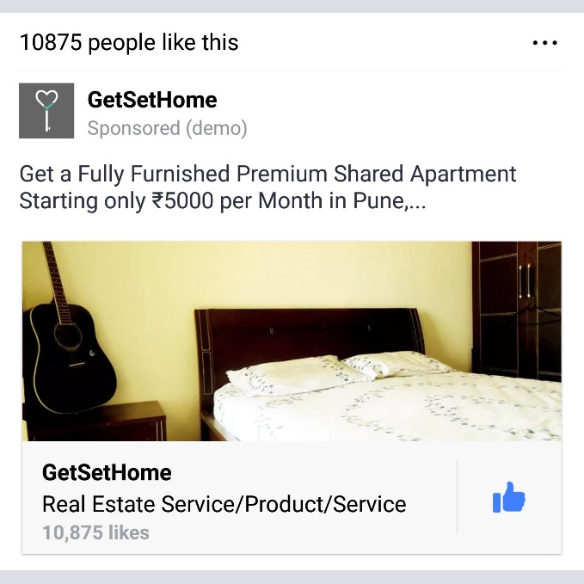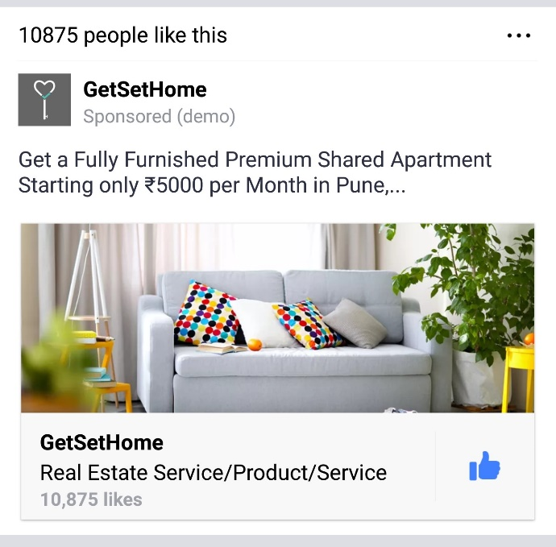**SAMPLE ADS:**